

KIIT Deemed to be University
Online Mid Semester Examination(Spring Semester-2021)

Subject Name & Code: Automata and Formal Languages(CS2010) Applicable to Courses: B.Tech(CSE/IT/CSCE)

Full Marks=20 Time:1 Hour

SECTION-A(Answer All Questions. All questions carry 2 Marks)
Time:20 Minutes (5×2=10 Marks)

Question No | Question Type(MCQ/SAT) | Question | Answer Key(if MCQ) | CO Mapping
Q.No:1(a) | MCQ | Question -1 on concept 1  Consider the following DFA ‘D’ given below:  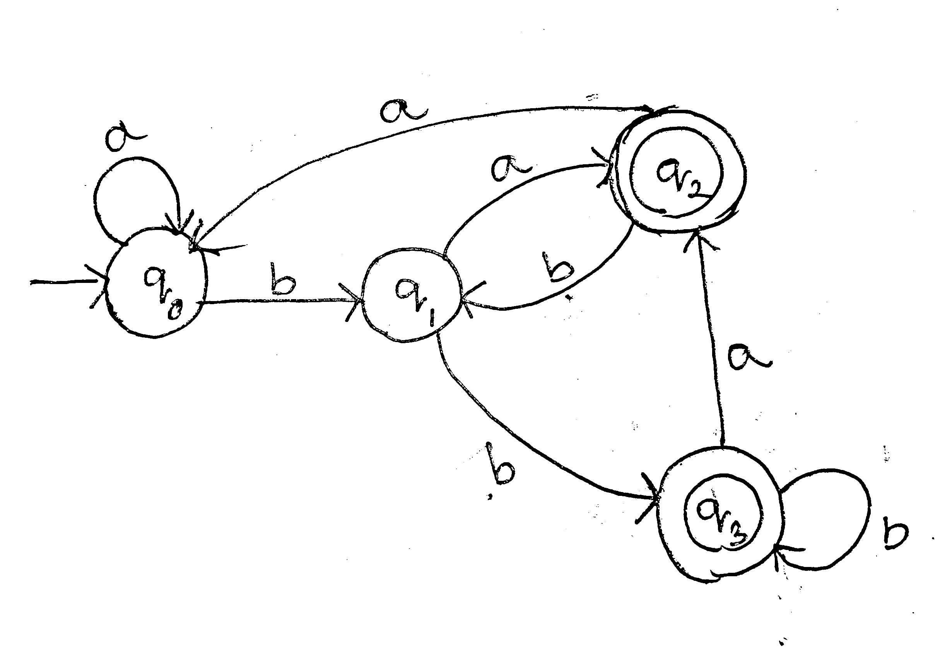  Which of the following language represented by L(D)?  - L(D)= { w ϵ⅀* | w is the string ending with “b”}  - L(D)= { w ϵ⅀* | |w| ≥ 2, second last symbol of w is “b”}.  - L(D)= { w ϵ⅀* | |w| ≥ 2, w is the string contain at least one “b”}.  D) L(D)= { w ϵ⅀* | w is the string not ending with “aa” }. | B)L(D)= { w ϵ⅀* | |w| ≥ 2, second last symbol of w is “b”}. | CO1
 | MCQ | Question -2 on concept 1  Which of the following represent language for given DFA ‘D’.  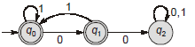  A) L(D) = { w | w ∈ (0 +1)*, w has no pair of consecutive 0’s}  B) L(D) = { w | w ∈ (0 +1)*, w has no pair of consecutive 1’s}  C) L(D)= { w | w ∈ (0 +1)*, w has a pair of consecutive 1’s}  D) None of the above. | A) L(D) = { w | w ∈ (0 +1)*, w has no pair of consecutive 0’s} | CO1
 | MCQ | Question -3 on concept 1  Consider the machine M,  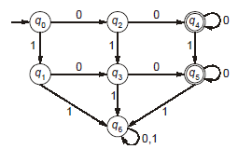  The language recognized by M is:  A) {w ∈ {0, 1}* | every 1 in ‘w’ is followed by a 0}  B) {w ∈ {0, 1}* | every string ‘w’ starts with ‘10’ or ‘01’ or ‘00’}  C) {w ∈ {0, 1}*| w does not contain ‘11’ as a substring}  D) {w ∈ {0, 1}*| w contains at least two 0’s and at most one 1} | D) {w ∈ {0, 1}*| w contains at least two 0’s and at most one 1} | CO1
 | MCQ | Question -4 on concept 1  What language does the following DFA compute?  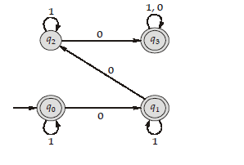  - {w | w is a string that contains exactly three 0's}  - {w | w is a string that contains one or three 0's}  - {w | w is a string that does not contain exactly two 0's}  - {w | w is a string that does not contain more than four 0's} | C){w | w is a string that does not contain exactly two 0's} | CO1
Q.No:1(b) | MCQ | Question -1 on concept 2  ⅀={a,b,0,1,x,y,z}  For the regular expression r= (a+b)*01(x+xy+z)*, how many different strings are possible of length less than equal to 4.  - 12  - 13  - 14  - 15 | C)14 | CO2
 | MCQ | Question -2 on concept 2  ⅀={a,b,c,0,1}  For the regular expression r= (a+ab+c)*0(0+1)*, how many different strings are possible of length less than equal to 3.  A)12  B)13  C)14  D)15 | C)14 | CO2
 | MCQ | Question -3 on concept 2  ⅀={a,b,x,y}  For the regular expression r= (a*+b*)*ab(x+y)*, how many different strings are possible of length less than equal to 4.  - 12  - 13  - 14  - 15 | B)13 | CO2
 | MCQ | Question -4 on concept 2  ⅀={a,b,x,y}  For the regular expression r= (a+b)*a(x*y*)*, how many different strings are possible of length less than equal to 3.  - 12  - 13  - 14  - 15 | B)13 | CO2
Q.No:1(c) | MCQ | Question -1 on concept 3  Let M1 be an NFA with 5 states and M2 be the minimized DFA with m states recognizing the same language. Then what is the maximum value of m ?  (A) 5  (B) 8  (C) 16  (D) 32 | (D) 32 | CO2
 | MCQ | Question -2 on concept 3  Consider the NFA which is given below. The number of states in DFA which is equivalent to NFA.  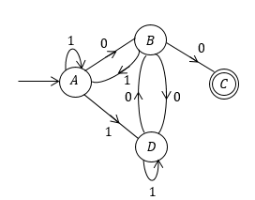  - 3  - 4  - 5  - 6 | C)5 | CO1
 | MCQ | Question -3 on concept 3  Consider the following statement:  S1: The power of NFA is less than power of NFA with λ-Move  S2: Given any NFA with two or more final states, there exists an equivalent NFA having one final state.  - Both statement are incorrect  - S1 is correct and S2 is not correct  - S1 is incorrect and S2 is correct  - None of the above | C)S1 is incorrect and S2 is correct | CO1
 | MCQ | Question -4 on concept 3  Consider the following NFA with λ -move  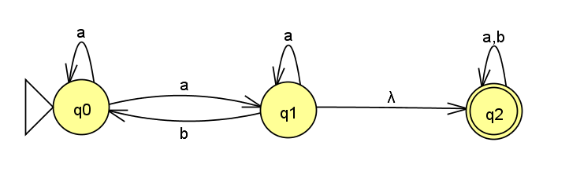  S1 : λ -Closure(q0) = {q0,q1,q2}  S2: λ -Closure(q0) = {q0}  - Both are correct  - S1 is correct and S2 is correct  - S1 is incorrect , S2 is correct  - None of the these | C)S1 is incorrect , S2 is correct | CO1
Q.No:1(d) | MCQ | Question -1 on concept 4  Let Let L = {w ∈ (a + b)*| w has even number of b’s}. Which one of the regular expressions below presents L?  - (a* b a* b)*  - a*(b a* b*)*a*  - (b a* b a*)*b*  - a*(b a*b a*)* | D)a*(ba*ba*)* | CO2
 | MCQ | Question -2 on concept 4  Which one of the following languages over the alphabet {0,1} is described by the regular expression: (0+1)* 0 (0+1)* 0 1*?  - All strings having at least two 0’s and ending with 0  - All strings having at least two 0’s and ending with 0 or 1  - All strings having at most two 0’s and starting with 0 or 1  - All strings having at most two 0’s and starting with 1 | B)All strings having at least two 0’s and ending with 0 or 1 | CO2
 | MCQ | Question -3 on concept 4  Which one of the following regular expressions represents the set of all strings over {x,y} with an odd number of x’s?  - x y* (y* x y* x y*)*  - (y* x y* x y*)* x y* + y*xy*  - (y* x y* x y* x y*)*  - (y* x y* x y*)* y* x | B)(y* x y* x y*)* x y* + y*xy* | CO2
 | MCQ | Question -4 on concept 4  Which one of the following regular expressions is NOT equivalent to the regular expression (p + q + r) *?  - (p* + q* + r*)*  - (p* q* r*)*  - ((pq)* + r*)*  - (p*q* + r*)* | C)((pq)*+r*)* | CO2
Q.No:1(e) | MCQ | Question -1 on concept 5  The regular expression for the language L={w{0,1}* | w has no pair of consecutive zeros} is  - (1+ 010)*  - (01 + 10)*  - (1+ 010)* (0+)  - (1+01)* (0+) | D)(1+01)* (0+) | CO2
 | MCQ | Question -2 on concept 5  Let a,b,c be regular expressions. Which of the following identities is correct?  - (a+b)* = a* b*  - a(b+c) =ab + c  - (a+b)* = a* + b*  - (ab + a) * a= a(ba +a )* | D)  (ab + a) * a=a(ba +a )* | CO2
 | MCQ | Question -3 on concept 5  Consider the language L given by the regular expression (a + b) *b(a +b) over the alphabet {a, b}. The smallest number of states needed in a deterministic finite-state automaton (DFA) accepting L is ______.  - 3  - 4  - 5  - 6 | B)4 | CO2
 | MCQ | Question -4 on concept 5  Which one of the following regular expressions represents the language: the set of all binary strings having two consecutive 0s and two consecutive 1s?  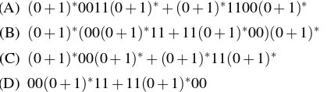  - A  - B  - C  - D | - B | CO2

SECTION-B(Answer Any One Question. Each Question carries 10 Marks)

Time: 30 Minutes (1×10=10 Marks)

Question No | Question | CO Mapping
Q.No:2 | A) Design a DFA for L={w1aw2: |w1| ≥ 3, |w2| ≤ 4} for ={a,b}  B) Design a DFA which will accept all the strings of length four or greater in which the leftmost three symbols are the same, but different from the rightmost symbol over the alphabet set {0,1} | CO1
Q.No:3 | A) Design a DFA for the language L={w ϵ (0+1)* | w contains an equal number of occurrence of 01 and 10}. For example, the string 01010 is in the language, where as 11010 is not in the language.  B) Minimize the following DFA 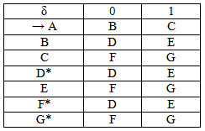 | CO1
Q.No:4 | A) Minimize the given DFA.  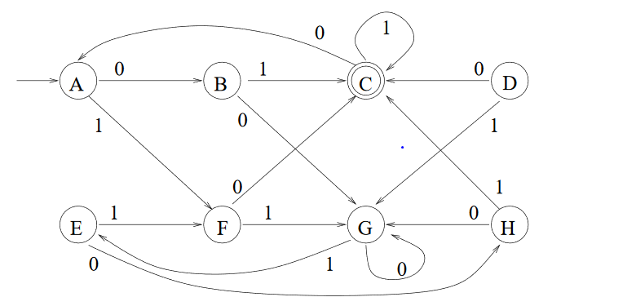  - Design an NFA with no more than five states for the set {abab^{n} : n ≥ 0} Ս {aba^{n} : n ≥ 0} | CO1,CO2
Q.No:5 | A ) Find the minimal DFA’s that accept the following languages:  - L= L(ab*a*) Ս L ((ab)* ba)  - L= L(ab*a*) ∩ L ((ab)* ba)  - Find regular expressions for the following:  - L= {w: (n_{a}(w) - n_{b}(w) mod3 ≠ 1)  - All the strings with at most two occurrences of the substring 00 over alphabet set {0,1}  - L= {a^{n}b^{m} : n ≥ 1, m≥1, nm ≥ 3}  - All strings not ending with 101  - All strings containing even number of 0’s over alphabet set {0,1,2,3} | CO1,CO2
Q.No:6 | A) Find the all strings of length three over the language L = (01 + 1)* 1 (0 + 01)*. Design an NFA with four states for the language L.  B)Provide the regular expressions for the following language specifications.  (i)L = {x^{n} y^{m} : n < 3, m <= 2}.  (ii)All strings over {a,b} not ending with ba.  (iii)L={w: |w| mod 3=0} over {0,1}.  (iv)All strings over {a,b} having exactly one pair of two consecutive a’s.  (v) L ={vwv : v,w ϵ {a,b}* , |v| =2} | CO1,CO2

Controller of Examinations

